**TDD USING JUNIT5 AND MOCKITO**

**Exercise 1: Setting Up Junit**

**Code:**

Calculator.java

**package** com.example;

**public** **class** Calculator {

**public** **int** add(**int** a, **int** b) {

**return** a + b;

}

**public** **int** multiply(**int** a, **int** b) {

**return** a * b;

}

}

CalculatorTest.java

**package** com.example;

**import** org.junit.Test;

**import** **static** org.junit.Assert.*;

**public** **class** CalculatorTest {

@Test

**public** **void** testAdd() {

Calculator calc = **new** Calculator();

*assertEquals*(5, calc.add(2, 3));

}

@Test

**public** **void** testMultiply() {

Calculator calc = **new** Calculator();

*assertEquals*(6, calc.multiply(2, 3));

}

}

**Output:**

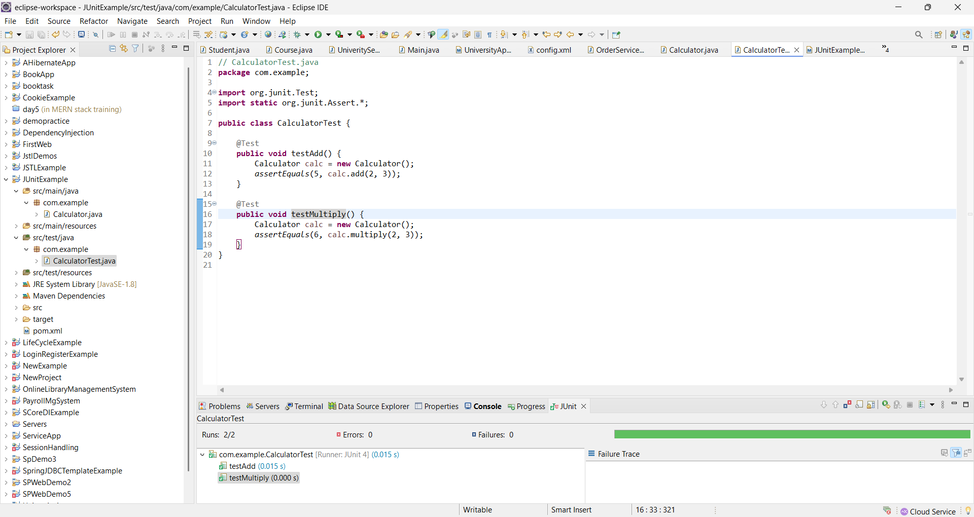

**Exercise 3: Assertions in Junit**

**Code:**

AssertionsTest.java

**package** com.example;

**import** org.junit.Test;

**import** **static** org.junit.Assert.*;

**public** **class** AssertionsTest {

@Test

**public** **void** testAssertions() {

*assertEquals*("Sum should be 5", 5, 2 + 3);

*assertTrue*("5 is greater than 3", 5 > 3);

*assertFalse*("5 is not less than 3", 5 < 3);

Object obj = **null**;

*assertNull*("Object should be null", obj);

Object nonNullObj = **new** Object();

*assertNotNull*("Object should not be null", nonNullObj);

}

}

**Output:**

